  - 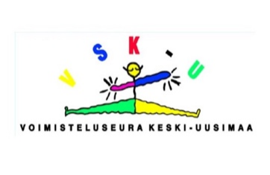
  - GYMNASTICS CLUB KESKI-UUSIMAA
www.vsk-u.net

Professional coach wanted

The gymnastics club Keski-Uusimaa is looking for a professional women's artistic gymnastics coach for its team for the 1st September 2022 to 31st of May 2023. VSK-U moves about 1,000 children, young people, and adults. We have a professional women's artistic gymnastics coaching team in our club.

We are looking for a coach to be responsible for the coaching of our gymnasts in the Gymnastics Federation's coaching groups, including the coaching of our club's two National Team athletes. Tasks include coaching planning and coordination, daily coaching, camps and competitions. As part of our club's competitive coaching team, you have opportunity to influence the coaching of our club's other competitive gymnasts.

We expect the applicant to be professionally motivated, committed and goal-oriented approach and ability to develop athletes to the best possible level. The applicant must have sufficient training in the field, good interaction skills and previous experience in coaching gymnasts at international level. The task requires good work community skills. According to the agreement, the employment relationship will begin in September. There is a possibility for a longer contract of employment.

The gymnastics club Keski-Uusimaa will move to a new premises in September 2022, located in the Tuusula Sports Centre. We offer comprehensive health services to the worker.

Free-form application with salary requests by 31st of May by email to Pirkko Haapala, the club's executive director haapala.pirkko@gmail.com

More information:
haapala.pirkko@gmail.com
weekdays 10-14 050-5678662

Check out our follow-up from Instagram to @veskulanvekkulit and NTV gymnastics @vskutytot

