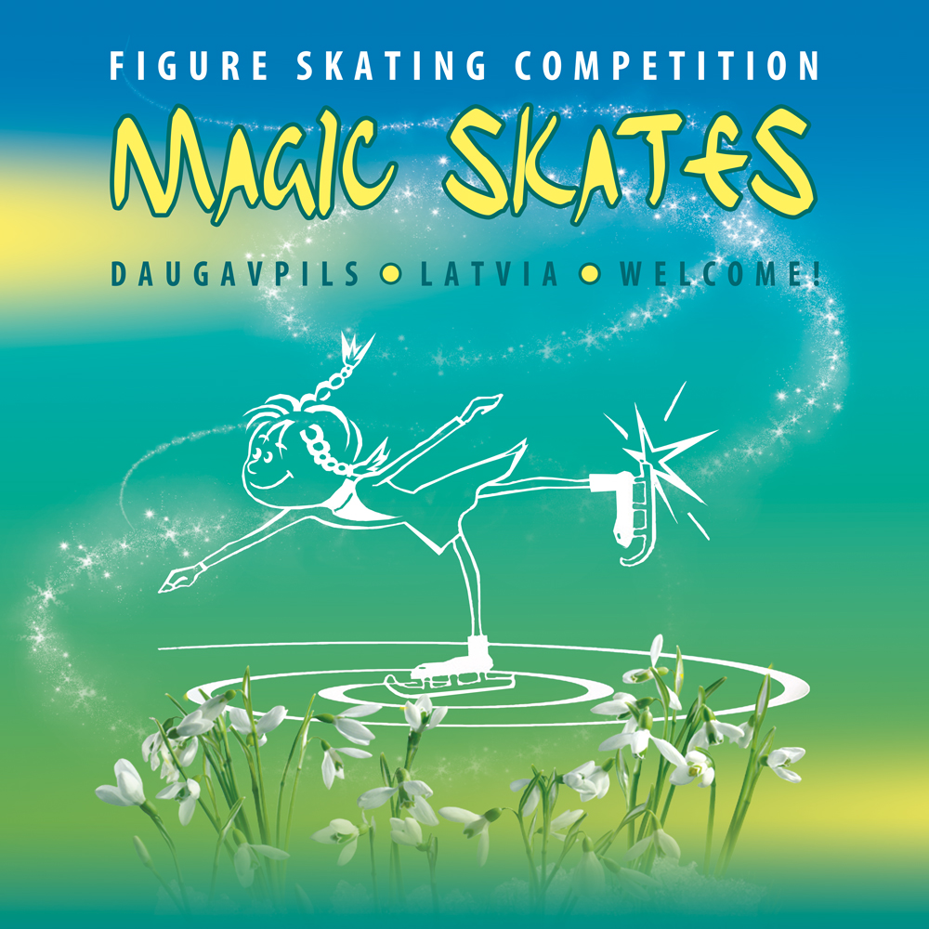

ANNOUNCEMENT / INVITATION

ORGANIZER: Children and youth sport school ,
IK Magic skates

Competition Secretary: Natalja Mishkovska
e-mail: www.magicskates.lv
mobile phone: +371 26888140
DATE: April 27-28, 2018

PLACE OF COMPETITION: Daugavpils Ledus Halle ,
Stacijas 47 a , Daugavpils, Latvia

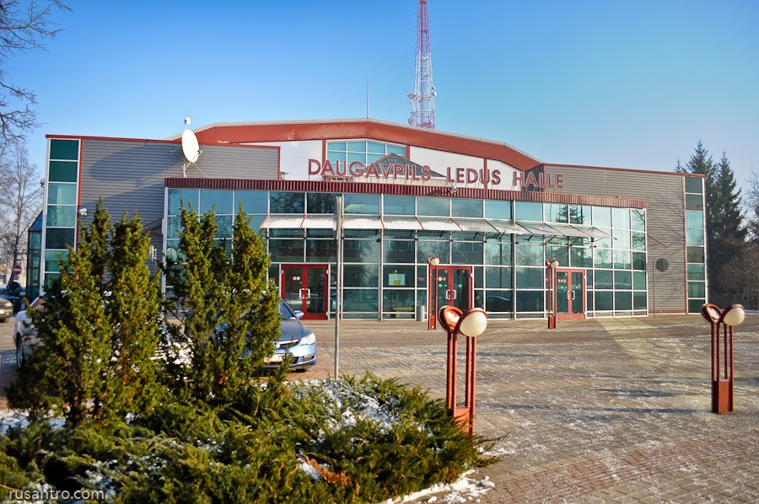

ENTRIES :

"Magic Skates" is being held as an individual competition. All clubs, members of National Figure Skating Federations associated with the ISU, are invited to take part in this competition. Entries must contain competitor’s full name, date of birth. The number of competitors is not limited.
Entries can be sent by e-mail on the address given below by 15.04.2018.
The deadline for entries is 15.04.2018.
Each club must confirm their final entry list on accreditation (mandatory).
E-mail: Natalja_Mishkovska@inbox.lv
All current information will be available on the website:www.magicskates.lv

CATEGORIES:

A class | Senior | Ladies, Men
 | Junior | Ladies, Men
 | Advanced Novice | Girls, Boys
 | Basic Novice A | Girls, Boys
 | Basic Novice B | Girls, Boys
 | Cubs | Girls, Boys
 | Chicks | Girls, Boys
 | Pre-chicks | Girls, Boys

B class | Junior | Ladies, Men
 | Springs | Girls, Boys
 | Cubs | Girls, Boys
 | Chicks | Girls, Boys
 | Pre-chicks | Girls, Boys
 | Beginners | Girls, Boys

All B Class categories will be judged according to the Technical data for season 2017/2018, Annex 2.

ENTRY FEE:
ISU Judging System

Single Skating with one program (A & B Class): 50€
Single Skating with two programs: 60€

A bill will be sent with the confirmation e-mail. Bill must be paid with one (1) transaction for all the club participants. You can change one skater for another in any category if it`s paid already in period from entries deadline to 24 hours before the drawing. Unpayed participant will not take part in drawing.
Organizer will not return entry fees but the participant’s prize will be awarded to the canceled participant or him/her team.
Recipient: Natalja Miskovska
(IK”Magic skates”) Nr.41502033204
Reg.ID: 260260-10238
Bank: SWEDBANK
Account: LV91HABA0551034377119

RESPONSABILITY:

In accordance to ISU Constitution, rule 119, all participants act at their own responsibility.

PROTESTS
Each team has the right to submit protest against the judges’ decision. Protests must be submitted to the Referee of the relevant event at the latest immediately after the event. Upon the submission of the protest a protest fee of 50 EUR must be paid. The referee’s decision is final. In the new ISU Judging Systems no protests can be filed against the judges (see Rule 123), but against the right determination of the executed element or any calculation error. Inte ISU Judging System protest can be summited in 24 hours after subsegmen (e.g. Short Program) and before the awarding ceremony after the final segment (e.g. Free Skating). Protest must be done in a writted form to the referee of the relevant segment. Please read ISU Rule 123.

THE CODE OF ETHICKS:

All the skaters,coaches,judges,chaperons should follow the ISU com. 1717, 1784 and 1853. Action against this rule conducts behind itself the disqualification of skater.

MUSIC:

Music will be reproduced from CD player. CDs must be labeled with names of competitors, club and category which they participate. CDs must be delivered not later than one (1) hour before the start of relevant segment. Music must be leaved on the accreditation.

PLANNED PROGRAM CONTENTS:

Planned program content sheets should be filled in and sent to the e-mail – natalja_mishkovska@inbox.lv
not later than 15.04.2018.

AWARDS:

The first three best placed competitors in each event will be awarded by medals, special presents and diplomas; others by diplomas and presents.

ENTRIES MODIFICATION:

Each participating club may change their participant`s category latest in period from entries deadline to 24 hours before the drawing. All changes submitted after the accreditation won`t be accepted.

RESULTS:

The results for (A class) Novice, Junior and Senior categories will be calculated according to ISU judging system.
Chicks – Cubs (A Class) will be calculated according to Adapted Classification for Youngsters for season 2017/2018 (attached in Appendix 2).
All the B Class and Beginners categories will be calculated according to „B Group Classification for season 2017/2018“(2nd part of Appendix 2) using ISU judging system.

Result information and detailed protocols will be available on listed website:www.magicskates.lv

DRAWING April 26, 2018 from 18.00 (electronic draw)

STARTING ORDER;
Starting order will be at the organizers websites April 26, 2018
www.magicskates.lv

EXPENSES:

All participants and teams must pay the accommodation and transportation themselves.

ACCOMMODATION :

- Park Hotel Latgola 3*: http://www.hotellatgola.lv/

- Home like Hotel 4*( 5min walk from the ice rink)

- SanMari (2min drive / 5 min walk from the ice rink)

- Biplan hotel Daugavpils 3* : www.biplan.lv

- Biplan city 3* : www.biplan.lv

- Hotel Leo 3* (+371) 654 26565 , lauma@apollo.lv

- Hostel (near Ice rink ) , (+371) 65423734:

- Hostel State Secondary School, Saules st.24, (+371) 65420611, http://www.latvia.travel/lv/naktsmitne/daugavpils-valsts-gimnazijas-dienesta-viesnica

