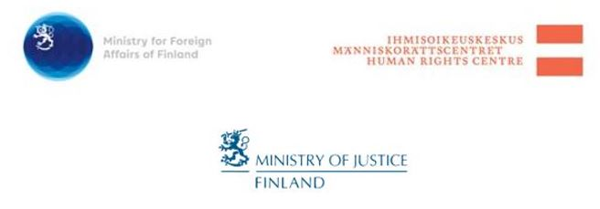

***INVITATION***

*STANDING UP FOR HUMAN RIGHTS IN A MULTIPOLAR WORLD - AN EVENT IN HONOUR OF MS. KATE GILMORE, UN DEPUTY HIGH COMMISSIONER FOR HUMAN RIGHTS*

Dear recipient,

The Human Rights Centre and the Ministry for Foreign Affairs of Finland in cooperation with the Ministry of Justice have the pleasure to invite you the event *Standing up for Human Rights in a Multipolar World* organized in honour of ***Ms. Kate Gilmore, UN Deputy High Commissioner for Human Rights***, during her visit to Finland on 13 April 2018.

At the event, Deputy High Commissioner *Gilmore* will deliver a Key Note speech. The speech will be followed by a panel discussion on what opportunities there are to stand up for human rights at a time when international law is challenged. Questions expected to be addressed during the discussions include for instance:

* What are the most critical human rights situations globally?
* What is the role of the UN and its Member States, the civil society, National Human Rights Institutions, business and other stakeholders in promoting and protecting human rights?
* What opportunities and challenges does the 2030 Agenda bring to the international human rights framework?

The event will take place at the auditorium of the Parliament Annex building, Arkadiankatu 3, Helsinki on 13 April 2018 from 9.00-11.30. The event will be in English with no translations.

Advance registration to the event at <https://www.lyyti.in/standup4rights> is required by **Monday 9April 2018 at 12.00.** Please also remember to kindly bring with you an ID upon arrival to the event. Please note, that due to security check at the Parliament Annex participants are advised to arrive early.

**Livestream** of the event will be available at <https://www.eduskunta.fi/fi/Sivut/live.aspx>.

Welcome!

Ministry for Foreign Affairs Human Rights Centre Ministry of Justice

**Standing up for Human Rights in a Multipolar World**

***AN EVENT IN HONOUR OF MS. KATE GILMORE,***

***UN DEPUTY HIGH COMMISSIONER FOR HUMAN RIGHTS***

***Parliament Annex building***

***Arkadiankatu 3, Helsinki***

***Friday 13 April 2018***

**PROGRAMME**

9.00-9.30 *Registration and coffee*

9.30-9.45 *Welcoming remarks*

* Ms. **Sirpa Rautio**, Director, Human Rights Centre

*Opening remarks*

* Mr. **Antti Häkkänen**, Minister of Justice

9.45-10.05 *Key Note speech*

* Ms. **Kate Gilmore**, Deputy High Commissioner for Human Rights

10.05-11.20 *Panel discussion*

* Ms. **Kate** **Gilmore**, UN Deputy High Commissioner for Human Rights
* Mr. **Martti Koskenniemi**, Academy Professor of International Law at the University of Helsinki, Director of the Erik Castrén Institute of International Law and Human Rights.
* Ms. **Niina Laajapuro**, Policy Director, Amnesty International – Finnish Section
* Ms. **Tytti Matsinen**, Human Rights Advisor, Finnish Evangelical Lutheran Mission (FELM)
* Ms. **Laura Okkonen**, Head of Human Rights, Nokia
* Ms. **Satu Santala**, Director General, Ministry for Foreign Affairs of Finland

Moderator: Ms. **Nina Nordström**, Director, Unit for Human Rights Policy, Ministry for Foreign Affairs of Finland

11.20-11.30 *Closing*

* Ms. **Sirpa Rautio**, Director, Human Rights Centre

**Livestream** of the event will be available at <https://www.eduskunta.fi/fi/Sivut/live.aspx>