NIR Mellanmøde 2019
NORDIC DESIGN SEMINAR

7 November 2019
Clarion Hotel Copenhagen Airport

PROGRAM

Welcome: Nicolai Lindgreen, attorney at law at Kromann Reumert and chairman FIR - Foreningen Industriel Retsbeskyttelse

10 – 11.30
- Setting the scene
General introduction and moderator: Jens Schovsbo, Professor, Centre for Information and Innovation Law, University of Copenhagen
- “The Design Approach: What is left and what is right?”: Annette Kur, Professor, Affiliated Research Fellow, Intellectual Property and Competition Law, Max Planck Institute for Intellectual Property and Competition Law | IP
- “Status on the EU reform”: Tomás Lorenzo Eichenberg, Principal Administrator, European Commission
- “View from the Danish Office”: Torben Kristensen, Principal Legal Adviser, Danish Patent and Trademark Office
LUNCH
- Design law in action
12.45 – 14.00
- EU and international protection
General introduction and Moderator: Ellen Breddam, Partner, Plougmann Vingtoft A/S
- “Practical guidance in regard to filing pitfalls and strategy when using the International Design System”: Bernard Volken, Attorney-at-law, Partner, FMP Fuhrer Marbach and Partner, Bern, since 2017, Lecturer at Tongji Universität Shanghai
- “Scope of protection and infringement under Community Design Law”: Henning Hartwig, Dr. jur., Attorney-at-Law, Partner, BARDEHLE PAGENBERG
- “Design protection and the interface to copyright law”: Jens Schovsbo, Professor, Centre for Information and Innovation Law, University of Copenhagen
BREAK
14.30 – 16.30
- Design law in the Nordic countries
General introduction and Moderator: Anne Marie Sejersted, Partner (H) / Member of the Board, Kvale Lawfirm
- “Design protection in the Nordic countries: Looking back and forward”: Linnea Harnesk - Associate Lawyer - Westerberg & Partners, Sweden
- Is there still a need for national design protection?
  - A view from industry: Marjut Alhonnoro, Senior Brand Protection Lawyer, Roschier, Helsingfors
  - A view from the offices: Hedvig Bengston, Senior Legal Adviser, Norwegian Industrial Property Office
  - A view from legal practitioners: Johan Løje, attorney at law, Løje Arnesen & Meedom
16.30 - 17
- Discussion: How can we make the system better?
Moderator: Jens Schovsbo, Professor, Centre for Information and Innovation Law, University of Copenhagen

Before and during the day think of the following issues which will be debated at the end of the day:
  - What (if any) should the EU reform change?
  - Is the EU Court moving design law in the right directions?
  - Is there a need for national design protection next to the EU-system?
Venue: Clarion Hotel Copenhagen Airport is right next to Copenhagen Airport, located just 2 minutes walking distance from Terminal 3.
Address: Ellehammersvej 20, 2770 Kastrup, Denmark
Phone to Clarion Hotel Copenhagen Airport: +45 32 50 15 01
Webpage: https://www.nordicchoicehotels.dk/hoteller/danmark/kastrup-lufthavn/clarion-hotel-copenhagen-airport/?utm_campaign=regular-pictures&utm_medium=organic&utm_source=googlemybusiness

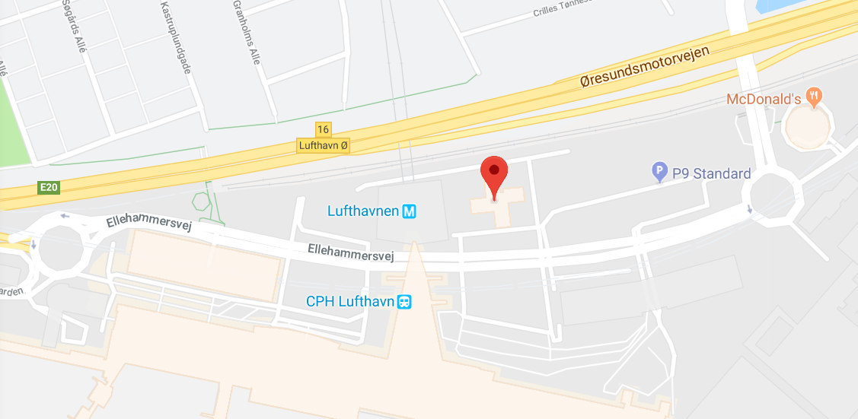
Fee and registration:
Registration by mail to: aippi@aippi.dk – before 15 October 2019.
Please enter your name, telephone number and e-mail. And please state to which company/address we shall send the invoice.
If you want to book a room at Clarion Hotel we have obtained a special offer of DKK 1.495,00 per night. When booking a room, please refer to the seminar in order to get the discount.
Conference fee: DKK 1.145,00. Included: coffee breaks and lunch. We confirm and send an invoice when we receive your registration.

