Washing labels
Study the washing labels from the given links or find them on the internet by searching with “washing labels”. Answer to the questions in the boxes and return it in the notebook. The questions are in three different pages.
https://www.which.co.uk/reviews/washing-machines/article/washing-symbols-explained#one
https://www.supersavvyme.co.uk/home/laundry/understanding-labels

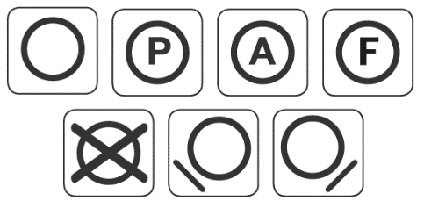
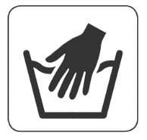
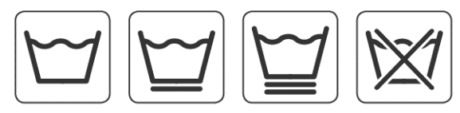
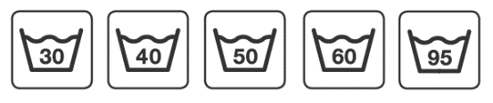
These labels are called:

- What does the tub icon mean in general?

- What is the line under the tub?

- What does the number (30, 40 …etc) within the tub?

- What does the hand in the tub mean?

- Some garments have a circle with a letter in it. What does that mean?

- What does the circle inside the square mean?

- What label means that tumble drying is forbidden?

- What do the square labels in the middle mean in general?

- What are the last 2 symbols?

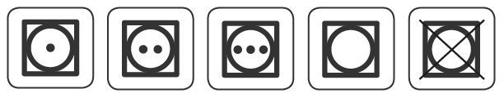
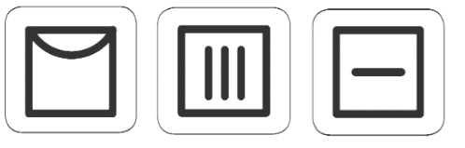
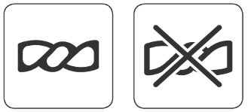
These labels are called:

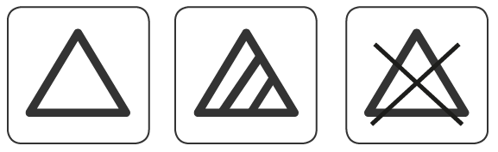
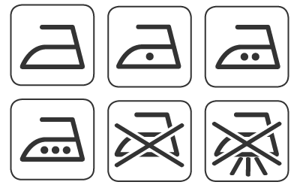
These labels are called:

- What does the triangle mean?

- What does the cross over mean in general?

- What do the dots correspond on the iron?

- What does the last ironing symbol with the cross and 3 lines on the bottom mean?

