**Model of the conference articles for the Geophysics Days: MS Word**

**A. Author1 ja B. Author2**

1 The Institute of the Author 1, a.author@institute.fi

2 Another institute of the author 2

# Abstract

*In this article, we describe how to prepare and submit a conference article (an extended abstract) for the Geophysics Days, the meeting arranged by the Geophysical Society of Finland. This guideline document has been formatted following the instructions given below. Consequently, the document can be used as a template to prepare the conference article. The maximum length of the article is four pages, preferably two or four pages due to layout. Also a Finnish version of the guidelines is available. The main body of the article is to be written in Finnish or English but the abstract always in English. We suggest the use of UK English.*

1. INTRODUCTION

Geophysical Society of Finland arranges Geophysics Days usually every second year. The meetings aim at providing information on new research and results between the geophysicists in different disciplines. The presentations (talks and posters) are collected into conference proceedings. Starting from the year 2022, a special issue will be also published in Geophysica journal on the topics of the meeting.

The authors are asked to submit their camera ready articles including figures in electronic form using, e.g. MS Word as done here. A LaTeX template is also available.

N.B. Conference proceedings are compiled from submitted articles without any editing work. Only page numbers will be changed. Therefore it is anticipated that authors submit the articles in the form they will have in the conference proceedings.

The purpose of the text below is to extend the article over page breaks and ensure that top and

bottom margins are correct.

This is only text fill. This is only text fill. This is only text fill. This is only text fill. This is only text fill. This is only text fill. This is only text fill. This is only text fill. This is only text fill. This is only text fill. This is only text fill. This is only text fill. This is only text fill. This is only text fill. This is only text fill. This is only text fill. This is only text fill. This is only text fill. This is only text fill. This is only text fill. This is only text fill. This is only text fill. This is only text fill. This is only text fill. This is only text fill. This is only text fill. This is only text fill. This is only text fill. This is only text fill. This is only text fill. This is only text fill. This is only text fill. This is only text fill. This is only text fill. This is only text fill. This is only text fill. This is only text fill. This is only text fill. This is only text fill. This is only text fill. This is only text fill. This is only text fill. This is only text fill. This is only text fill. This is only text fill. This is only text fill. This is only text fill. This is only text fill. This is only text fill. This is only text fill. This is only text fill. This is only text fill. This is only text fill.

2. INSTRUCTIONS FOR THE PREPARATION OF THE ARTICLE

1. The level of difficulty: pan-physical. Language: Finnish or English. Abstract always in

English.

1. The length of the article: 1-4 pages, preferably 2 or 4 A4 pages.
2. Conference proceedings will be posted on the internet as a single pdf-file, which can contain colour figures.
3. Accepted file formats: .doc, .docx, .odt ja .tex.
4. Margins: left and right 25 mm, top and bottom 30 mm. The top margin of the first pages is 50 mm.
5. Font Times New Roman 12, line spacing 1. Exception: **The title of the article** with font size 14 and bold. After one empty line, bf Author(s) with font size 12 and bold and, again after one empty line, affiliation. Address in not included but the email address of the first author (corresponding author) can be given after the affiliation. The lines in the header section are centered. The *Abstract* in italics and justified. Both the title and text always in English.
6. The titles of other chapters are numbered and written with capital LETTERS and aligned to the left side. One empty line between the chapter title and each paragraph. The first lines of paragraphs are not indented. Text in all chapters is justified. The title of the references (not numbered) is REFERENCES. Refer to in the text as, e.g., Author (2002) or Tekijä et al. (1991). It is recommended that the references in the list are given as in Geophysica (see: <https://www.geophysica.fi>).

3. FURTHER INFORMATION

Here you can see further information for formatting the conference article. In particular, please keep an eye on figure formatting guidelines.

This is only text fill. This is only text fill. This is only text fill. This is only text fill. This is only text fill. This is only text fill. This is only text fill. This is only text fill. This is only text fill. This is only text fill. This is only text fill. This is only text fill. This is only text fill. This is only text fill. This is only text fill. This is only text fill. This is only text fill. This is only text fill. This is only text fill. This is only text fill. This is only text fill. This is only text fill. This is only text fill. This is only text fill. This is only text fill. This is only text fill. This is only text fill. This is only text fill. This is only text fill. This is only text fill. This is only text fill. This is only text fill. This is only text fill. This is only text fill. This is only text fill. This is only text fill. This is only text fill. This is only text fill. This is only text fill. This is only text fill. This is only text fill. This is only text fill. This is only text fill. This is only text fill. This is only text fill. This is only text fill. This is only text fill. This is only text fill. This is only text fill. This is only text fill. This is only text fill. This is only text fill.

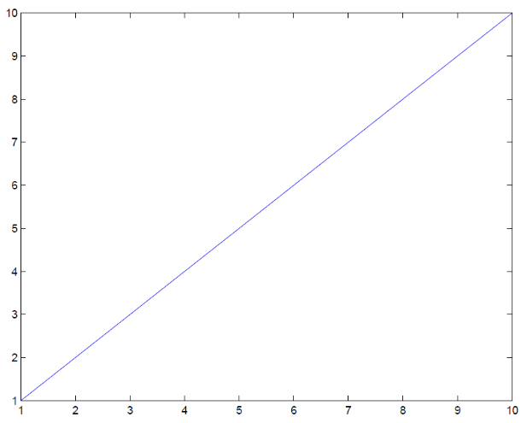

Figure 1: A poor example of an illustration with a caption beneath it. The caption should be center-aligned if located below the illustration.

‘



Figure 2: A poor example of an illustration with a caption on its side.

ACKNOWLEDGEMENTS

The form (format) of the conference article for the Geophysics Days is a result of long work, where several local organizing committees as well as the editors of the proceedings have contributed. The original word-version of the guidelines and the LaTeX files were compiled by Reijo Rasinkangas (University of Oulu, Department of Physics) for the Geophysics Days 2003. We are grateful for the original version as well as for several updates of the LaTeX files.

REFERENCES

Author, A., 2002. A very, very long title of the article to check how the reference extends to the second line, part I. *Some Geophysical Journal or preferably its abbreviation*, **100**, 1-10.

Tekijä, A., B. Tekijä ja C. Tekijä, 1991. Another article with a shorter title, part II*, J.R.S.P. (Journal of Rejected Scientific Papers)*, **77**, 123-134.