DRILL NAME |  | Passing with angles
CONTENT |  | Basic position, pivoting, passing technique
OBJECTIVES | - Work in passing the ball
 | - Work in receiving the ball
GRAPHS
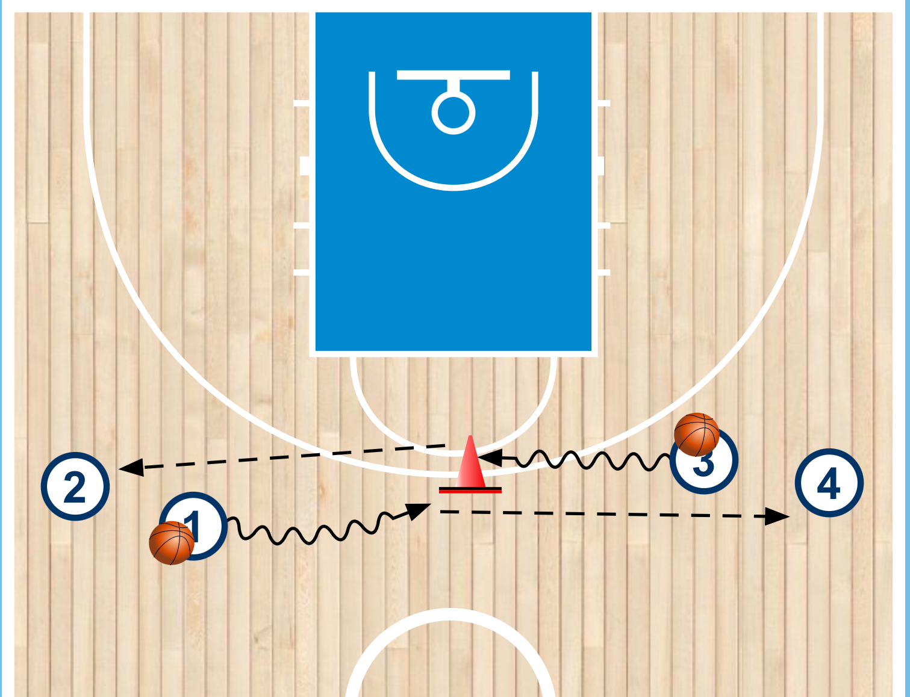
DRILL DESCRIPTION |  | In groups of 4 players at least, they have to go one in front the other to look for the best angle to do the pass to the next teammate.
PROBABLE MISTAKES |  | - Players dont pivot when passing the ball  - Bad receptions
CORRECTIONS |  | - We have to work in the passing technique. (Pivoting, using wrists and elbows, protect the ball)  - Hands ready to get the ball

