DRILL NAME |  | Inbound Peli 2v1
CONTENT
OBJECTIVES
GRAPHS
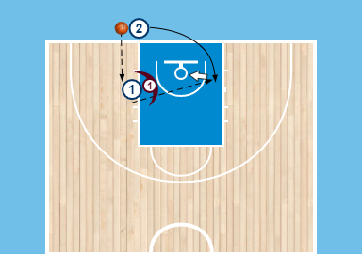
DRILL DESCRIPTION |  | We practice making contact, holding, passing away from the defender
PROBABLE MISTAKES
CORRECTIONS

