DRILL NAME |  | Close out
CONTENT |  | Defense technique/Tactic
OBJECTIVES | - To practice closing out to ball
 | - Ready to close middle
GRAPHS
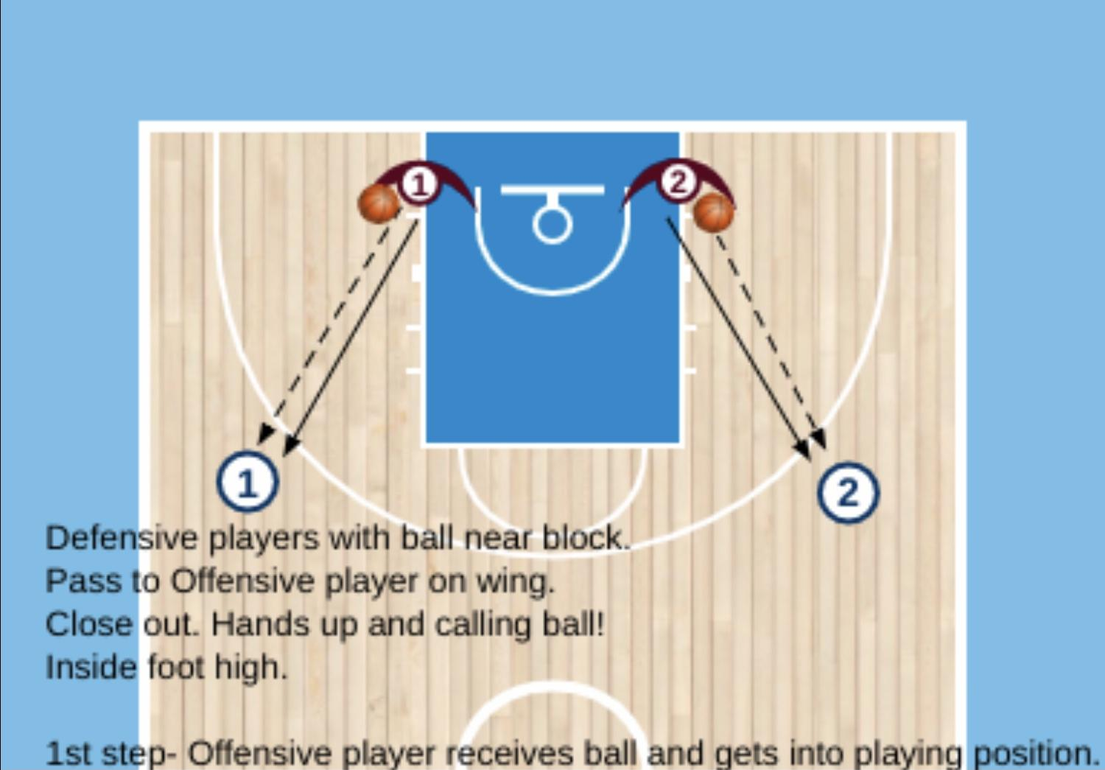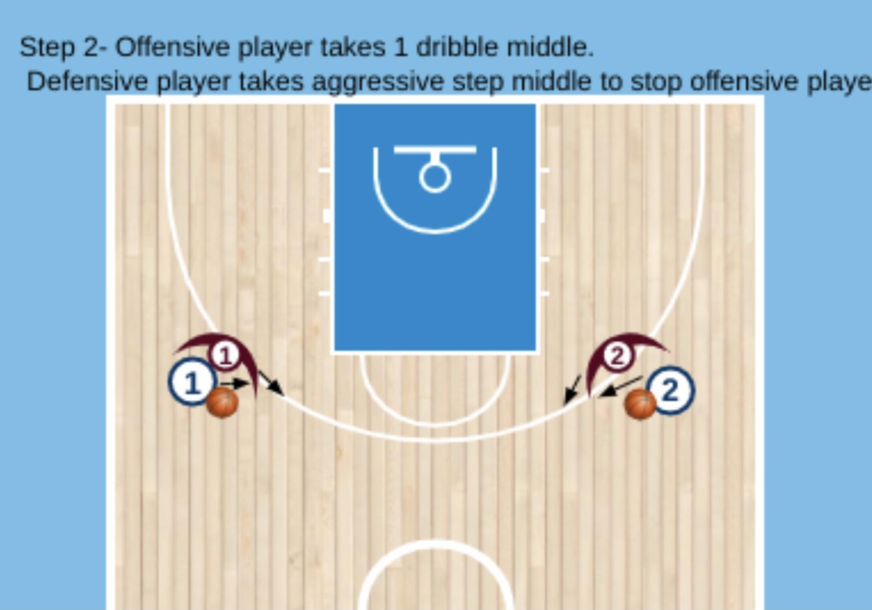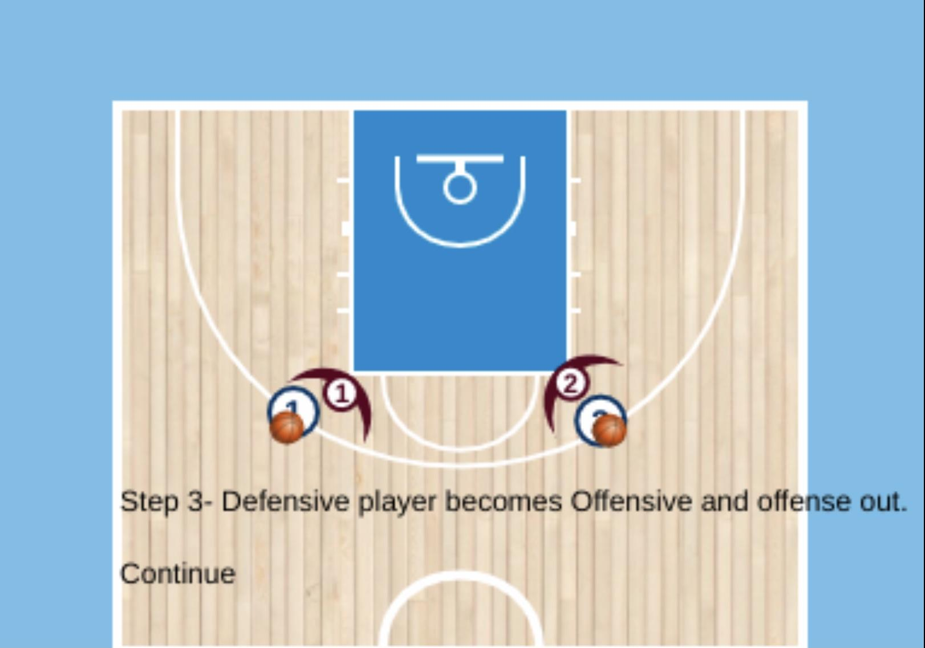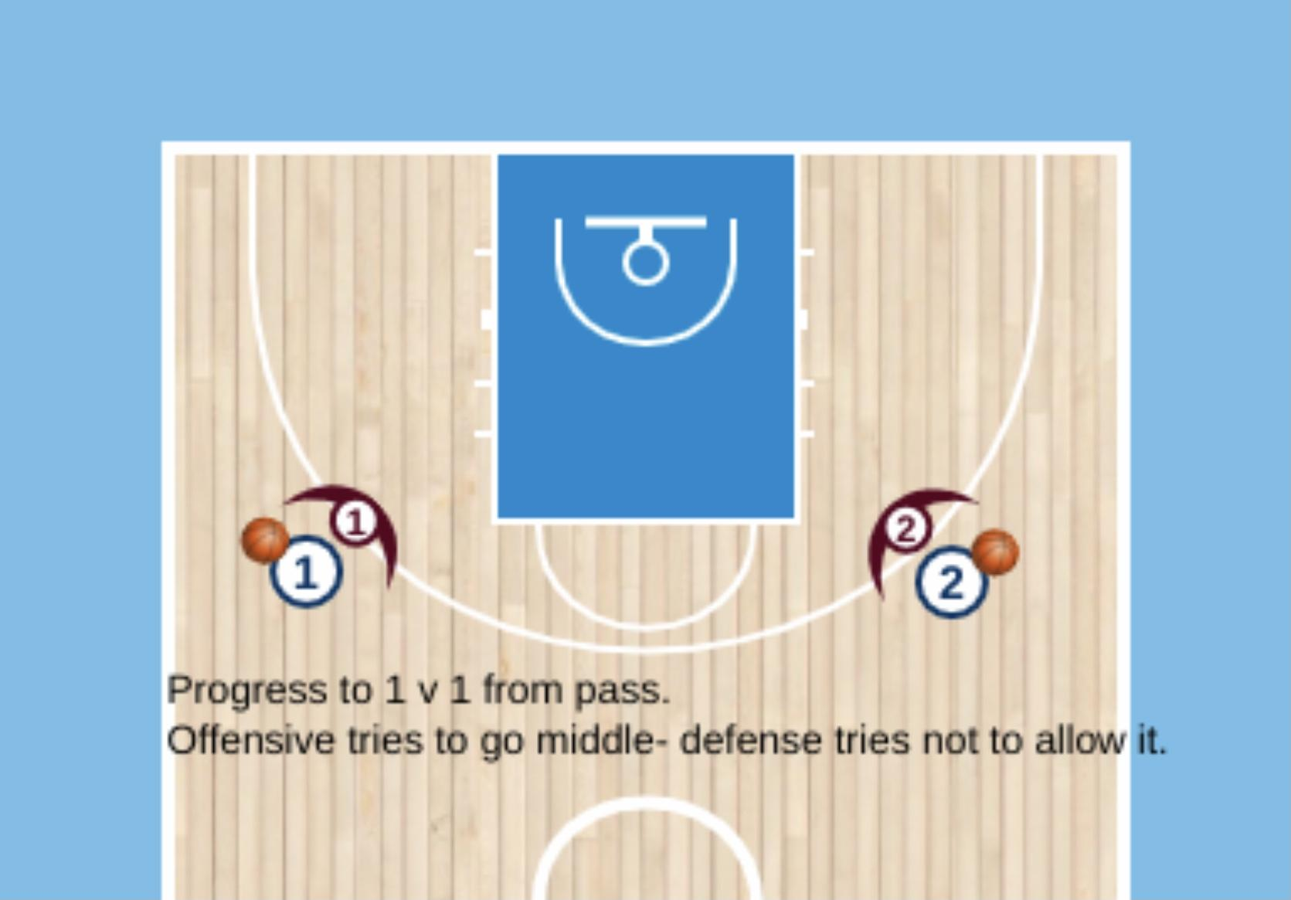
DRILL DESCRIPTION |  | 1 defender with ball on block or under the basket.  Passes to offensive player and closeout.
PROBABLE MISTAKES |  | - Too long steps to close out  - Bad defensive positioning
CORRECTIONS |  | - Defender must close out with short steps, ready to react.  - We have to remember the players to deny middle.

