DRILL NAME |  | 1c1 chased
CONTENT |  | Finishing / Defending
OBJECTIVES | - To be able to finish with a defender chasing you
 | - Try to recover in defense after getting beat.
GRAPHS
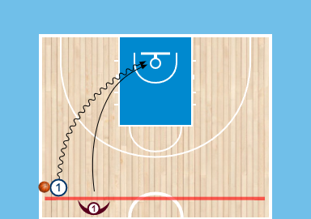
DRILL DESCRIPTION |  | 1 starts ahead of D1. 1 have to finish in the paint. D1 has to stop 1 from scoring.
PROBABLE MISTAKES |  | - Players dont use superiority.  - Players just want to attack or defend
CORRECTIONS |  | - Incitivate finding the open teammate for better chance of success  - Make them understand that in basketball you are 50% of your time defending and 50% attacking.

