DRILL NAME |  | First pass and help side - Shell Drill
CONTENT |  | Defensive concepts (First passing line, Help side, defensive communication)
OBJECTIVES | - Defensive recovery to reach 1x1 situations (bigs and wings) Denying middle and defending posts.
 | - Help side: Put into practice when to go help side and who gets there depending on where I am; over or under FT line
GRAPHS
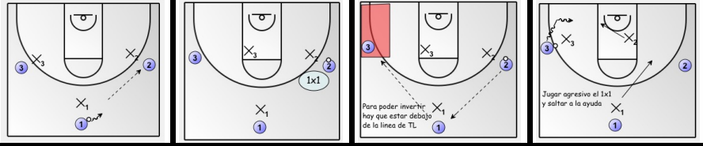
DRILL DESCRIPTION |  | From the middle we pass (over dribble or we approach) the ball to the player on ball side. Player will attempt 1v1 from wing position or interior position. If he can’t, passes again to player in the middle and we initiate movement. Player in the middle may only pass to weak side if the player is below FT line (same if inverted again). We work on the defence of the first passing line and we jump on help side if drive.  We may introduce a fourth player with a defence which will be in the post (bigs work on rotation independently). Defence will jump to help and we must rotate on defence accordingly)  Rotations: Central offensive player > Offense to the side he just defended // Central defender > Central offense  Finisher > Defend weak side // Finisher’s defence continues to play defence (consequence)  Defensive help side > Central defense  Offense help side > Continues to play offense  Variations: With bigs (They only switch between them and sometimes we bring them to the wing, if we are transforming a player)  Drill starts with no BS or OBS, and progressively they will be acquiring concepts, so then we can add screens.
PROBABLE MISTAKES |  | - Rotations (they are not aware that they’re on help side) Focus problems  - Big defensive player gets rebound: ROTATION (Help side is the opposite of rebounder)  - Quick steal on 1v1 (change roles offense-defense)  - Defence of big and help side
CORRECTIONS |  | - Scale from the most basic (3v3) to the most complex (4v4)  - Posture adjustment (feet, body, hands) in both first and second passing lines  - When and how to jump to help side (defensive premises)  - Motivation to speak on defense

