DRILL NAME |  | 1c1 Handicapped
CONTENT |  | Offensive tactic/ 1c1
OBJECTIVES | - Read the advantage in a 1c1 situation
 | - How to recover after being beaten
GRAPHS
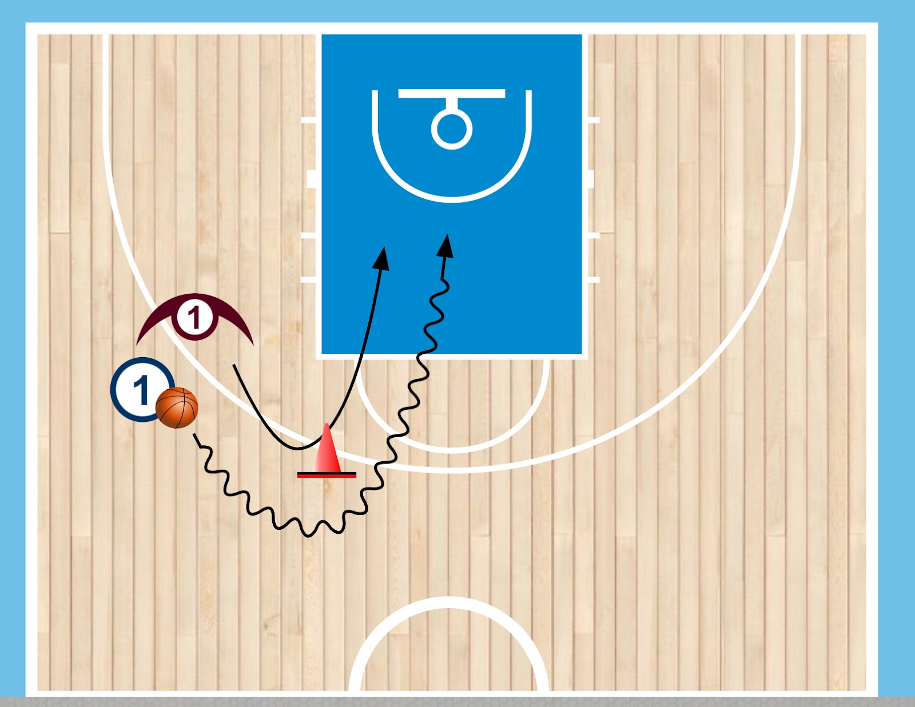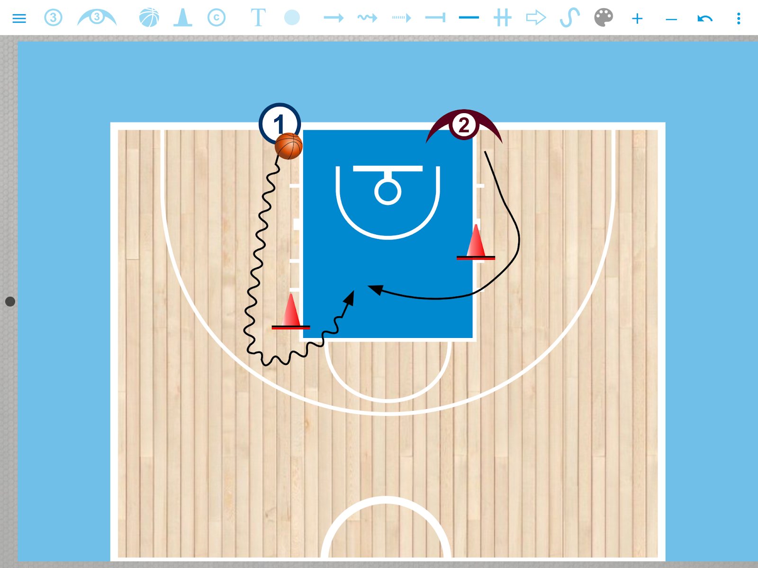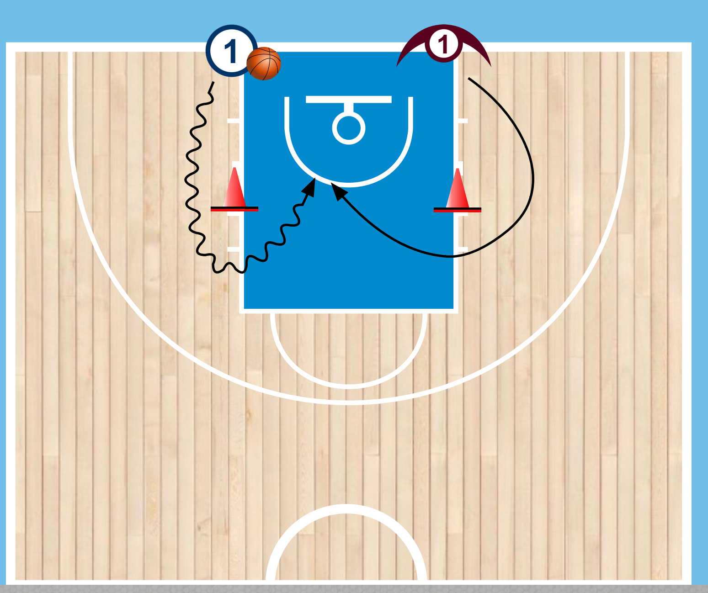
DRILL DESCRIPTION |  | 1x1 where offense starts. When ofense starts, defense can go. Offense must round the cone with only one dribbling, and defense touches the cone before going to stop the player.  We can do hundreds of variants here. Imagine situations of the game and try to simplify. Here are some examples.  VARIANT:  Another option, focus on the reading too, is make the defender put their feet with right foot or left foot forward, and make the offensive player attack the foot that is forward, to break his or her balance. After the first dribbling defender can play defense
PROBABLE MISTAKES |  | - Bad reading  - Lazy defense
CORRECTIONS |  | - Good readings will come with time, but we have to give easy cues to the defense. For example: “When you drive, if you see the shoulder go straight, if you see chest change direction”  - We have to make players understand that the better they defend, the better their teammates will be.

