DRILL NAME |  | Two ball + Spacing
CONTENT |  | Spacing, dribbling, one handed passes
OBJECTIVES | - Space according to the ball
 | - Passing the ball
GRAPHS
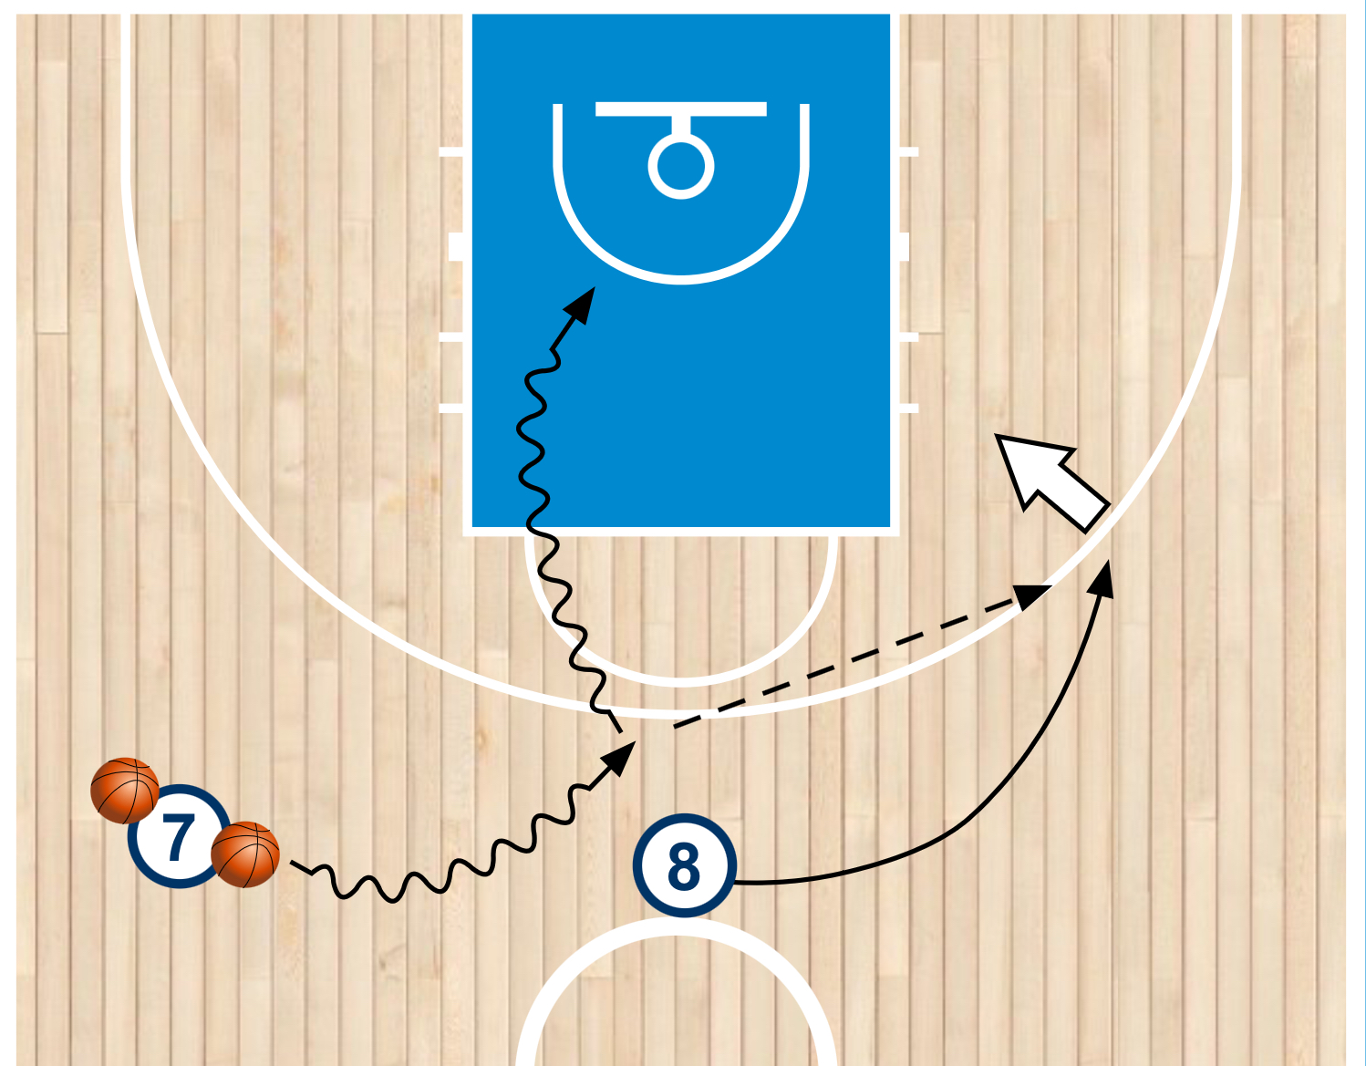
DRILL DESCRIPTION |  | One player has two balls and starts dribbling from middle court. Player without the ball has to move, keeping space with the ball. When the player wants, makes a pass to his teammate. This player that is receiving will choose if to shoot or take a lay up. The other player will have to read the situation. If my teammate goes dribbling to make the lay up, will take a shot. If he takes a shot, then the player will go dribbling to do the lay up.
PROBABLE MISTAKES |  | - Bad passing  - Bad reception
CORRECTIONS |  | - When they pass we want them down too, opening the elbow to get the move from there to the wrist and fingers, opening the angle  - Player who receives the pass must be ready to catch with hands ready to shot.

