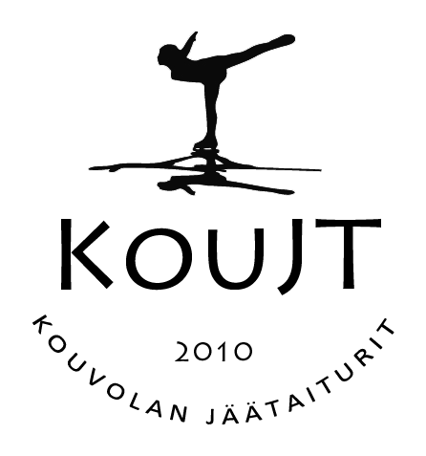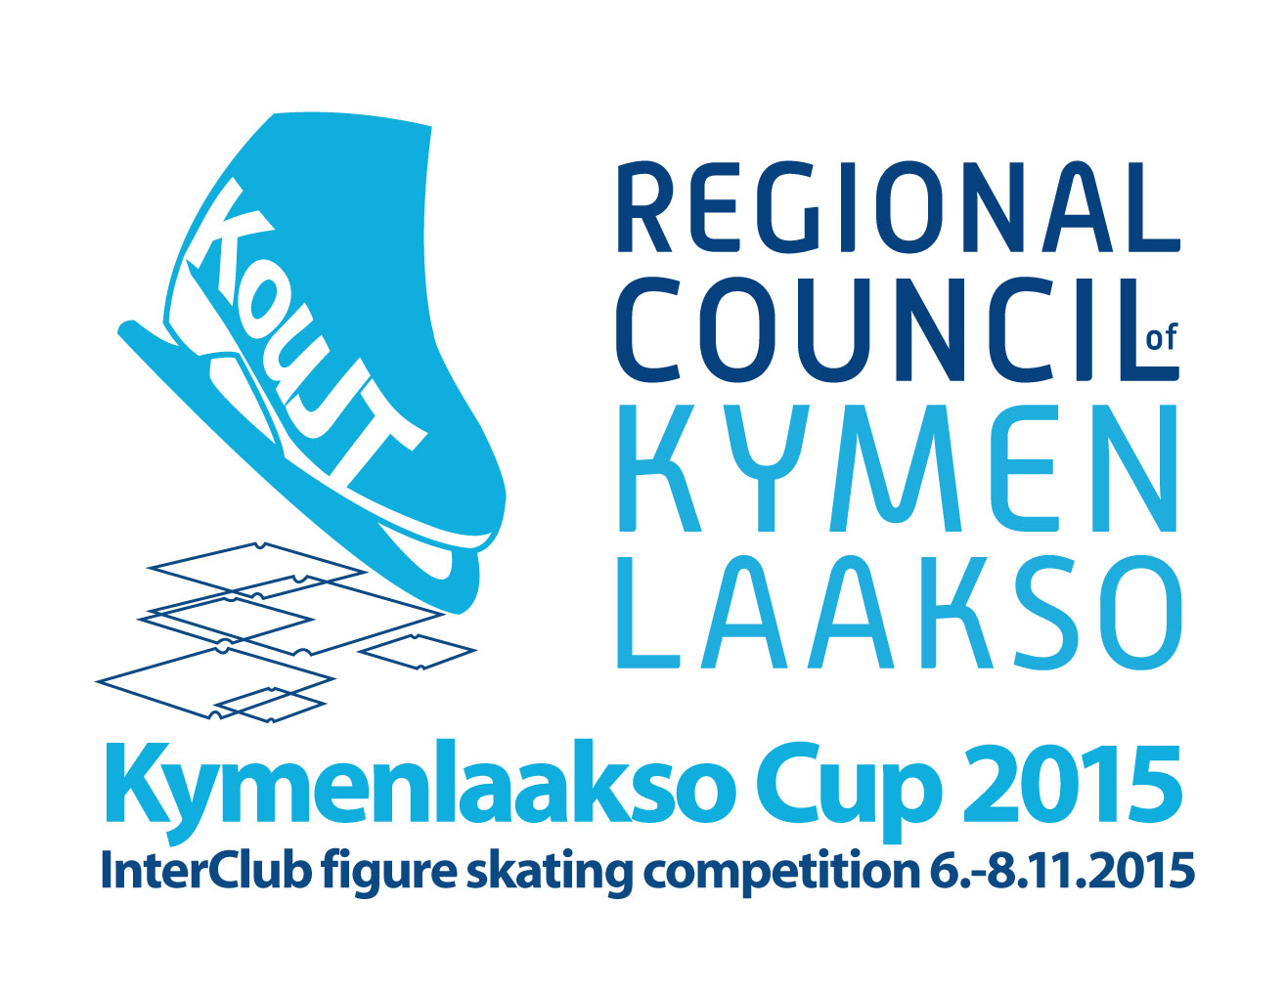INTERNATIONAL
Figure Skating
Competition
Kouvola, Finland

Planned Program Content, Single Skating, only FS

Club:
Category:
Name of the competitor:

Elements in order of skating – terminology according to ISU Communications

 | Time | Elements FS
1
2
3
4
5
6
7
8
9
10
11
12
13

Date, signature

Returned at the latest: Sunday, October 18th 2015 kisat.koujt@gmail.com

