**Benefits of EFIC membership for national chapter members**

The list below indicates the benefits available to the individual members of EFIC chapters. These benefits should be communicated by Councillors to their chapter members in order for those individuals to be able to take advantage of them.

**Congress**

* We provided a reduced congress registration rate to members of EFIC chapters. This should be clear in the registration categories. Example below:

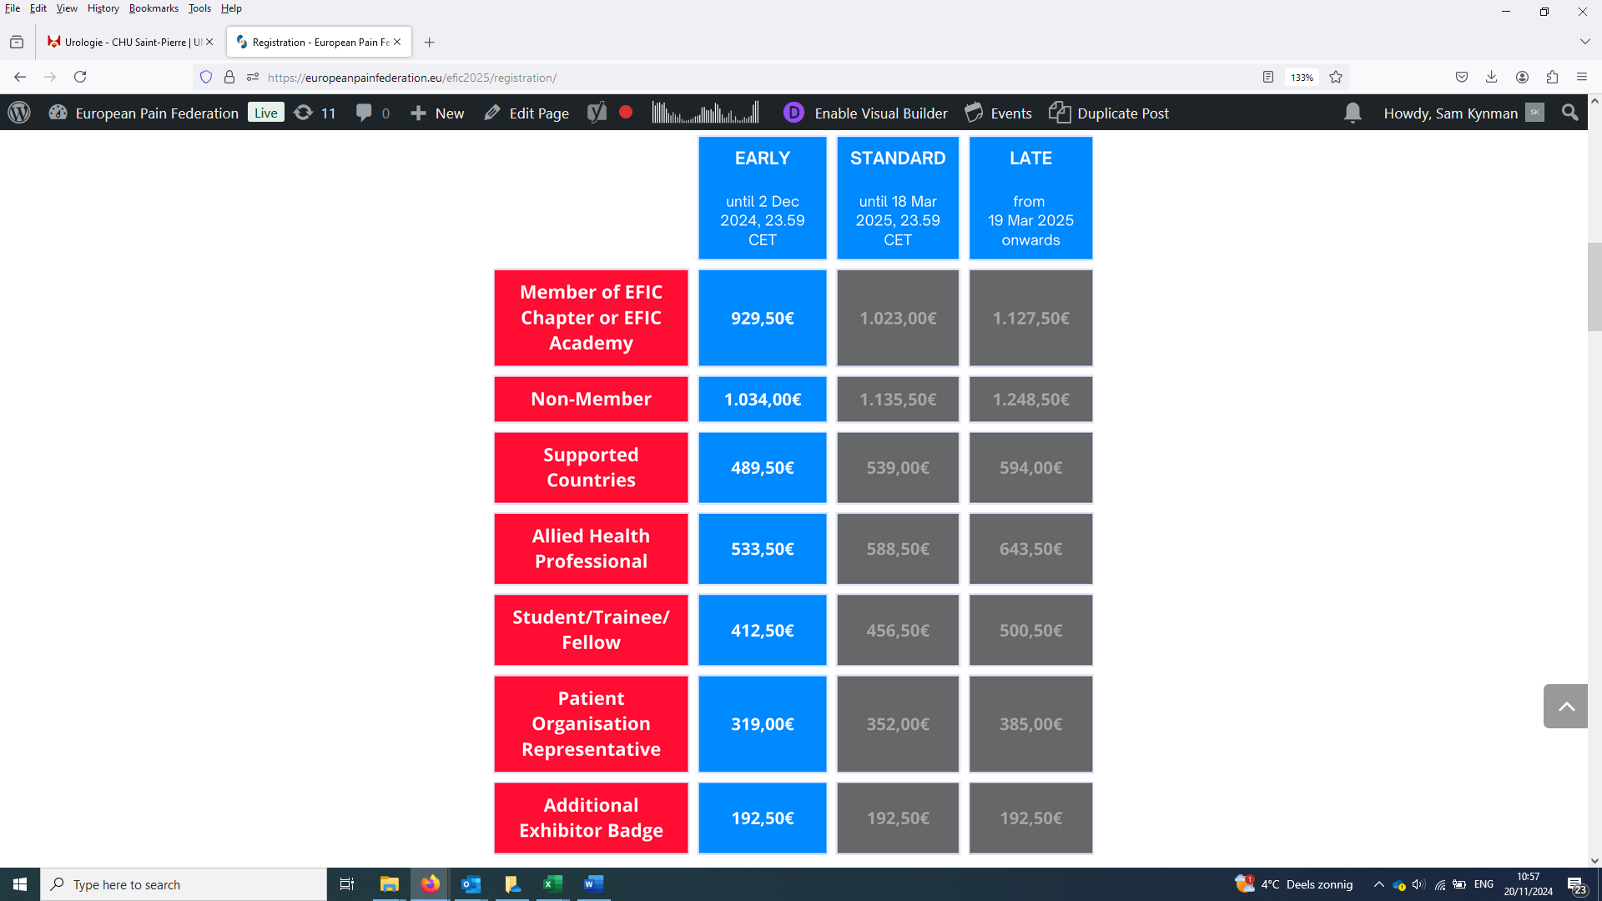

Please note that individual chapter members may qualify for other reduced categories. Attendees can choose the most generous category that applies to their circumstances.

* During the financial aid distribution process, where EFIC selects some individuals for free registration, we take note of applications that come from EFIC chapters. You should distribute the call for applications when it is launched – especially for lower income countries where registration even with discounts will be challenging.

**EFIC Academy**

* We provide discount codes for chapters to distribute amongst their membership in order for their members to benefit from additional reductions to the standard registration rates. See below.

The discount code is redeemable during the registration process, where the payment system allows for discount codes to be added on top of all standard registration rates. We currently offer a **15%** additional reduction for chapter members.

As a reminder, Academy membership gives them access to an e-learning platform, a biennial live virtual education event and various other benefits and discounts.

Please let us know if you would like to be provided with a new code to share with your members.

**European Journal of Pain**

* All national chapter members are entitled to free access to the European Journal of Pain (EJP). Access is enabled through this [sign-up form](https://europeanpainfederation.eu/european-journal-of-pain/registration-for-national-chapter-members/). From here, EFIC will take care of activation for the login on the EJP Wiley page.

The EFIC team may periodically ask Councillors to confirm whether a person claiming free access to the journal is an actual member of the chapter.

* National chapters with their own scientific journal are given permission to translate a selection of articles from the EJP into their own-language journals, provided the terms of copyright are followed. Detailed instructions on how to follow these rules are being circulated regularly. If you would like more information, please contact [secretary@efic.org](mailto:secretary@efic.org)

**Pain Schools**

* When deciding on the distribution of funded places at EFIC Pain Schools, EFIC tries to prioritise strong applications recommended by EFIC Councillors. The recommendation is not the only factor considered. We also try to ensure good geographic balance, appropriate educational level, English language competence, and multidisciplinary representation. However, between two more-or-less equally weighted candidates, a Councillor recommendation will take precedence.

We recommend that chapters distribute the calls for application as early as possible. Chapters are free to decide how they issue recommendation letters. You may wish to seek requests from eligible individuals directly before passing these on to EFIC. If you are familiar with eligible candidates in advance, you can push these candidates to apply with a recommendation letter.

**EFIC-supported speakers at national scientific meetings**

* All national chapters have the right to request support from EFIC towards the provision of a high-level speaker at their national scientific meetings. EFIC will liaise with a speaker or provide someone directly from the Executive Board and cover their travel and accommodation. Such requests should be made at least 6 months in advance. Any requests made later than this will be handled as best as possible. If you have a particular preference for a topic, you can make this known in the request and we will do our best to accommodate it.
* With or without an EFIC-designated speaker, EFIC can provide endorsement and promotional support for national meetings.

**Promotion of national chapter meetings and activities via EFIC**

* EFIC offers a range of opportunities to promote the events and activities of its national chapters, ensuring they reach a broad and engaged audience. Events can be featured prominently on the EFIC website, including in a dedicated [events calendar](https://europeanpainfederation.eu/events/), in the “[News from our Chapters](https://europeanpainfederation.eu/news-from-our-chapters/)” section or in the “[Abstracts from National Chapter Meetings](https://europeanpainfederation.eu/news/abstracts-from-the-european-pain-federation-efic-chapter-meetings-2024/)” section.
* Additionally, EFIC supports promotion through its regular mailings and posts on social media where relevant, highlighting key national chapter initiatives and events.