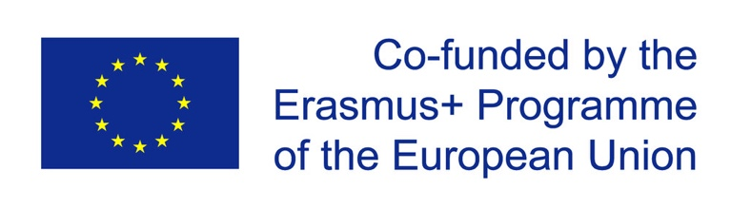

INFOSHEET

Erasmus+ Project

PEACE OF MIND

18. -29.07.2022
Magnet House, Dositeja Obradovica 34, Veliki Gaj (Serbia)

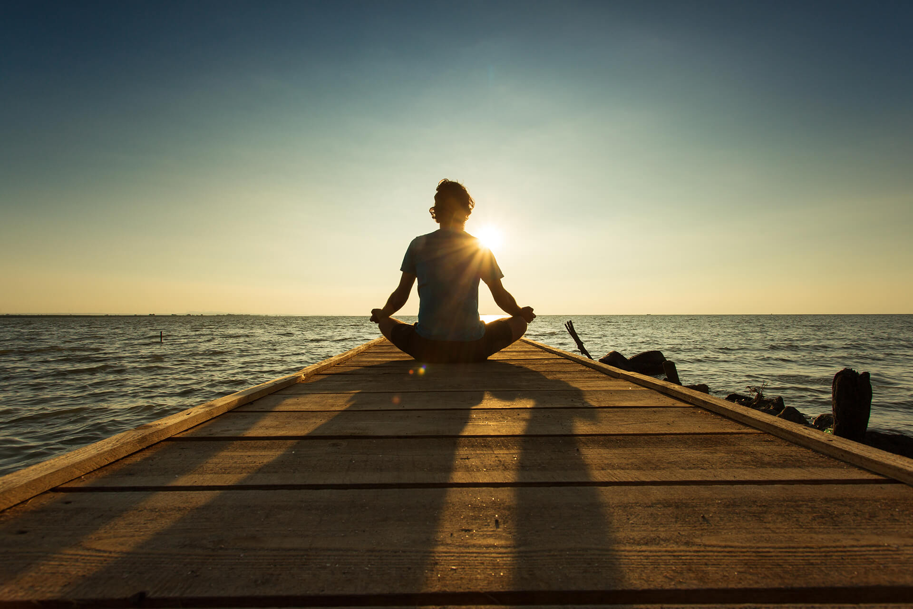

Have this document at hand when traveling, if asked by the border authorities
to prove the purpose of your travel

Contact Person:
Dusan Milojevic: duschan.milojevich@gmail.com
WhatsApp or Viber: +38163633334

ABOUT THE PROJECT

IJGD team has identified and shared some of the same concern with partner organisations regarding the challenges we find in youth work. Most of the challenges that were not related to the technical side of our job were narrowed down to one single point - lack of selfcare and self-support tools and mechanisms which would support our own well-being, empower us and allow us to avoid the burnout and emotional breakouts. Furthermore, the same concern has been identified in regards to organizations we work for – the lack of capacities, skills or knowledge of the tools that would allow us to have a support needed for the psychological and emotional recharge in situation of conflicts, work in stressful or emotionally overcharged settings, work with young people who require our full attention and devotion or simply work overload and long working hours in constantly changing contexts of the youth work. With an aim to address this challenge, IJGD plans to gather trainers in nonformal education with particular set of skills in self-development, psychotherapy, meditation and mindfulness, to develop a programme which will address this issue and support youth workers themselves in how to process high demands educational programmes have in regards to emotional and psychological support of the participants, especially among those coming from vulnerable groups and how to self-regulate stressful elements of their work, in order to provide and create more attentive, empathetic and emotionally supportive learning environment for their beneficiaries, as well for themselves and their colleagues. Afterwards, we plan to organize a youth exchange, so to try to transmit the said practice to the field.

AIM of this project is to provide more quality emotional support to young people involved in youth work programs of partner organisations, through empowering of youth workers to take care of their own and their participants’ emotional well-being.

The project will consist out of 3 activities:

A1: Introductory training course (7 working days): here participants were presented with basic theories and techniques surrounding the topic, namely on psychological support, working with vulnerable groups, mindfulness, yoga, meditation and other techniques. Activity was hosted in Serbia by MAGNET.

A2 and A3: Project will host two youth exchanges, each 10 working days, for participants age 18-25. One youth exchange will be hosted in germany by IJGD, while the second one will be hosted in Serbia, by MAGNET.

A2 dates: 18-29. July in Serbia
Countries involved: Serbia, Finland, Slovenia, Macedonia, Bulgaria, Cyprus
Number of participants: 4+1

A3 dates: 15-26. August in Germany
Countries involved: Germany, Serbia, Estonia, Portugal
Number of participant: 4+1

ABOUT THE YOUTH EXCHANGE IN SERBIA

The youth exchange will gather 24 participants plus 6 leaders (one for each group) from Serbia, Finland, Macedonia, Cyprus, Bulgaria and Slovenia, for a 10-day program. The program and methods will be prepared together with leaders of each group, also taking into consideration needs and interests of young participants.

Educational and training content and methodology:
- non formal education
- learner centred
- experiential learning
- exercises aimed at stress release and relaxation
- peer sharing and support

The methods that will be used are experiential, used in non formal education contexts of learning: games and energizers/brainergizers, exercises, icebreakers, team-building games, movement exercises, discussions, work in groups, role play, timeline, norm critical approach, image theater, living library, photo voice, community journalism.

Free time activities:
We will organise a visit to the town of Vršac for an entire day and will discuss other options for free time activities in and nearby Veliki Gaj. Otherwise, the group is invited to self-organise free time activities in the center and the village. We are open for all suggestions. There is a high quality projector available for movie nights, so think about bringing your favorite movie!
https://www.tripadvisor.com/Attractions-g304104-Activities-Vrsac_Vojvodina.html

Agenda:
During the 10 working days, there will be at least 2 90 minutes long workshops during the day and part of the day dedicated to volunteer work in Magnet house, the yard or in the village. We will have one free day, when we plan to organise an excursion to Vrsac.
Final agenda with topics of workshops and time-frame will be ready at least 10 days before departure to Serbia.
Each group and their leader will be in charge of organizing part of the program and offering workshops on different topics.

VENUE
Magnet House, Dositeja Obradovica 34, Veliki Gaj, Serbia

Magnet House is an international education center tailor-made to fit the needs of non-formal education. It is developed by the youth workers, for the youth workers, civil society sector. It is managed by Magnet Association, host of this project.
Magnet House gathers people who believe in free education, education for all, lifelong learning outside school, from one’s own and peer experience.

The center is located 90 min away from Belgrade and Timisoara, in a small village Veliki Gaj. The centre has rooms with 3-8 beds, large working space and a big garden. WiFi connection is available. For more information about the center, you can check our addresses:
Instagram @magnet.house
Website www.magnet.house

Meals: Three meals per day and 2 coffee breaks will be provided. We will be having a cooking team who will be cooking for us during the youth exchange. Two meals will be prepared by our cook and one meal per day (lunch or dinner) will be the responsibility of participants. Participants are expected to support the cook by helping with dishes and cleaning. We will take into consideration all the allergies and dietary restrictions, providing vegetarian and vegan meals and enough snacks throughout the day.

OFFICIAL START

Depending on your arrival times, we will organise a minibus to pick you up either from Belgrade or Timisoara or Vrsac. Further instructions on the exact time and place will follow once we have all your arrival times and airports.

Official start of the youth exchange is 8PM on the 18th of July 2022 at Magnet House. Departure is on July 29th after breakfast, also with organised transport to Belgrade or Timisoara, from where you will continue with your travels.

TIPS FOR ORGANISING YOUR TRAVEL

If you are coming to Belgrade or Timisoara, make sure to be there at the latest at 6PM on the 18th of July, so we can organise a smooth travel so you are in the center by the official start.

For exceptions, we would organise individual transfer (if there is no other option or the other flights are too expensive).

You may extend your stay before or after the training. Have in mind it is on your own expense and organisation and it shouldn’t be longer than 4 days total.

Include the flexible ticket change, in case of covid and if possible the travel health insurance with covid cover (change of flight, testing, hospitalisation and medication, quarantine lodging and food). This cost will be reimbursed.

If you need assistance with this, contact Dusan Milojevic at duschan.milojevich@gmail.com or via WhatsApp/Viber at +38163633334

FINANCIAL CONDITIONS

The participants will have their travel, food and accommodation covered for the international training of camp leaders following the standard Mobility of Youth Workers under Erasmus+ (food and accommodation 100%, travel up to 275 for all participants except participants from Serbia, who will be getting reimbursed 20 EUR for their travel, while participants coming from Macedonia, Slovenia and Bulgaria would receive up 180 EUR for travel costs.

Travel reimbursement for the International Training in Serbia will be done upon the receipt of all the tickets, no later than 2 months after the training, to the bank accounts of participants or their sending organisations, once we have received all the original tickets and boarding passes. Please, make sure to save all your boarding passes, tickets and invoices. Without them we can not reimburse you but also can not justify the training costs, so it is very important you do so.

Please collect all the invoices, boarding passes (DO NOT check in with your mobile boarding pass, but choose the option that the boarding pass is sent to your email), tickets, because we will be able to refund your travel only for the costs you are able to prove by the original documents, which we should keep.

Wherever possible choose online tickets and boarding passes, rather that paper tickets, as it will ease the reimbursement greatly and there will be no costs for mailing them by post with the risk of losing them.

Taxi is not refunded unless you had no other means of transport available. Only 2nd class train tickets and economy class plane tickets will be refunded, meaning the most economical way of transport.

WHAT TO BRING

Magnet House will provide the bed sheets and towels. We’re expecting hot summer this year, and the climate in this part of Serbia is also quite humid. So, bring a lot of comfortable summer clothes, but also something a bit warmer for possible colder evenings.

You should bring with you the following:
- Toiletries
- Your favourite game: cards, board games
- Bring house shoes or sneakers you will use only inside, so we keep the place tidy for ourselves
- Something to inspire creativity of the others
- Bring some snacks for international coffee breaks, music you like, movies
- Comfortable clothes for physical activities, yoga, etc.
- Clothes suitable for working outside (gardening, cleaning, etc)
- Yoga mat, if you have one

Veliki Gaj is a small village on the border with Romania. There are no ATM machines so please have this in mind and come with the money exchanged in Belgrade. Have in mind that 3 meals and 2 coffee breaks are provided.

In the village there is one grocery shop and one bar, so not much opportunities to spend money. However, there is an exquisite goat farm that produces cheese, winery, and we will be going to nearby Vrsac for an excursion during free time, where you can buy souvenirs and such.

Bring your passport or ID card. European Union citizens can enter Serbia with one of these two documents. In case you are coming to Serbia earlier to the arrival day, please have your host register you in the police, as it is obligatory to do in the first 24h after entering the country.
INSURANCE
Please make sure to buy the travel health insurance that has the COVID related coverage included (possibly with quarantine accommodation, return ticket home, testing, hospitalisation and medication). This cost is acceptable for funding and will be reimbursed.

COVID RELATED INFORMATION AND MEASURES

There are no COVID related requirements to enter Serbia. Also, there is no requirement to wear a face mask anywhere except in medical facilities. However, you are free to follow procedures of your country everywhere in the country, including at the Magnet House. There will be rapid tests available for you to use at the center.

For your return to your country of residence, please inform yourself regarding the requirements on the websites of the Ministry of the Foreign Affairs for the country where you reside.

TIPS FOR STAY IN BELGRADE PRIOR OR AFTER THE TRAINING

In case you arrive earlier to Belgrade, we highly recommend renting an Airbnb. There are many options and are very affordable. Many offer also the pickup from the airport.

For moving around Belgrade and using public transport, you can either:
- Buy a daily ticket that costs 250 dinars in every kiosk
- Buy the ticket for one ride at the bus driver for 150 dinars
- Pay by the Master Card by pressing the card against the machine in the bus, for 98 dinars
- Nighttime bus services run from midnight to 4 am and require purchasing a special ticket on board.

We recomend downloading an app Movit to your phone and use it for orientation and bus numbers. Belgrade’s public transport system also offers a handy app for Android and iOS where you can track the locations of all buses in proximity.

Make sure your host registers you in the police, as you are required to do so in the first 24h upon entering the country. If it is a hotel, they will do it automatically, but with Airbnb, make sure to ask before confirming.

Finally, the city has made use of modern tech in helping you get around smoothly, including the local version of Uber – CarGo

https://belgradegets.digital/discover/

