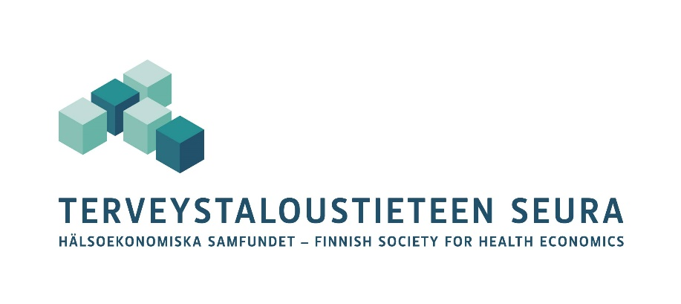

Call for Papers
Health Economics PhD Student Workshop

May 15th, 10 am –

JSBE/Labour Institute for Economic Research LABORE (Helsinki)

We encourage all PhD students working on health economics topics to present a paper or ongoing research (work in progress) at the workshop. Each paper will be discussed by a senior researcher.

The workshop will be organized at Labour Institute for Economic Research LABORE, Helsinki. See https://labore.fi/en/contact/

We encourage students to take this opportunity to learn to present their work.

Send in abstracts, extended abstracts or full drafts to Petri Böckerman at petri.bockerman@labore.fi by April 30th, 2026. Notifications will be sent by May 4th, 2026.

Organizer:
Petri Böckerman, University of Jyväskylä, Email: petri.bockerman@labore.fi

