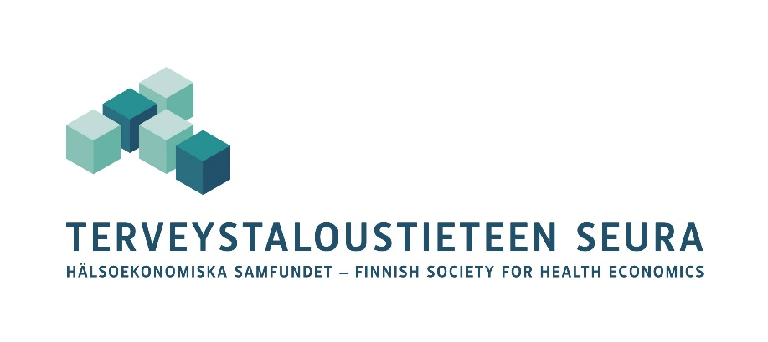

Call for Papers

Health Economics PhD Student Workshop

**May 9th, 9am –**

Hybrid seminar at Tampere University

We encourage all PhD students working on health economics topics to present a research plan, manuscript or ongoing research (work in progress) at the workshop. We will assign longer slots to presentations of more advanced stage papers. Each paper will be discussed by a senior researcher. The papers and presentations may be in English or Finnish.

The workshop will be organized as a hybrid event at Tampere University, Unit of Health Sciences, Kauppi campus. Students are encouraged to attend and present their work either in person or online in Zoom.

We encourage students to take this opportunity to learn to present their work.

Send in abstracts, extended abstracts or full drafts to Leena Forma, [leena.forma@tuni.fi](mailto:leena.forma@tuni.fi) by **Friday April 25th, 2025**. Notifications will be sent by Wednesday April 30th, 2025.

Organizer:

Leena Forma, Tampere University

Email: [leena.forma@tuni.fi](mailto:leena.forma@tuni.fi)