21.4.26

Invitation to share memories of the Viittakivi International Centre

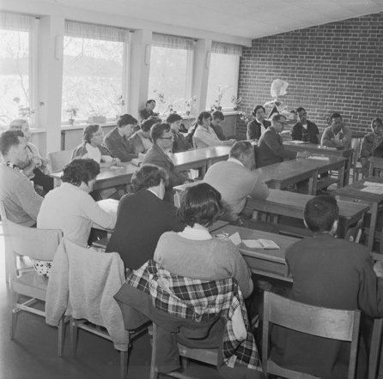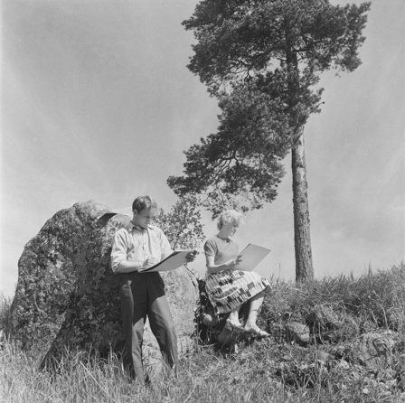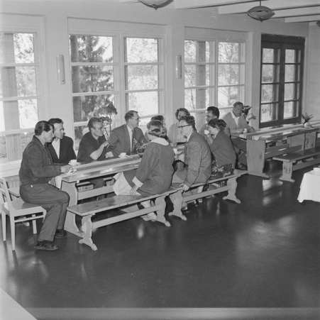

Welcome to participate in the data collection for the Viittakivi International Centre for World Peace 1951–2007. The Viittakivi International Association is gathering interviews to preserve memories of Viittakivi. This data collection is part of the project Viittakivi – Promoting International Understanding and Peace, funded by the Niilo Helander Foundation.

Do you want to get in touch with, or meet, someone you know from Viittakivi?
Invite them to participate in an interview. The interview themes focus on everyday life and activities in Viittakivi that promoted mutual understanding, community and world peace.

All collected material will be archived for future research (e.g. Finnish Data Archive or similar).

If you join us, please read this information, which includes the interview guidelines (before the interview, carrying out the interview, after the interview) and information on group interview meeting, reimbursing interview expenses, consent, privacy protection and contact information.

The deadline for the interviews is 16.8.26. Interviews can also be carried out during group interview meetings in Hauho on 4.6.26 or in Helsinki at Rauhanasema on 15.8.26.

It is also possible to respond to the interview in writing (Webropol, https://link.webropolsurveys.com/s/viittakivi).

1 Interview Guidelines

1.1 Before the interview

Contact communications coordinator Jenni Pätäri (see contact information below) to inform us of your intention to participate and to ask any questions you may have.

The interviewee and interviewer may choose to participate anonymously, under a pseudonym, or with real name. The researcher will remove personal identifiers from the data and pseudonymise any sensitive information.

The intended duration of the interview is approximately 30–60 minutes.

All interview participants are welcome to join a gathering and group interview meeting in the summer 2026, either at Hauho (Viittakivi premises) or in Helsinki (Rauhanasema & hybrid) (more information below).

1.2 Carrying out the interview

Use the interview questions in Appendix 2.
Record the interview using a smartphone recording app or another digital recorder. You may also conduct the interview online and use the recording function of the virtual meeting platform (e.g., Teams or Zoom).

1.2.1 Start of the recording: consent

When the recording begins,
- Report the date
- inform the interviewee and ask for consent to the following statements:

Informed consent:
- I am participating voluntarily in this interview.
- I consent to the recording of the interview.
- I consent to the transcription of the interview.
- I consent to the transcription being archived for future research purposes.
- I consent to the recording being archived for future research purposes.
- I understand that the data may be used for research without a time limit.

Identification (for both the interviewer and interviewee):
I wish to participate in the interview
- anonymously.
- under the pseudonym X.
- with my real name.

1.3 After the interview – how to send the audio file

Please contact communications coordinator Jenni Pätäri (jenni.patari(at)sivistystyo.fi) and you will get instructions for sending the audio file.

The recording will be sent for professional transcription (Tutkimustie, see https://tutkimustie.fi) and the transcripts will be archived for future research purposes.

Once the interview has been transcribed, you will be notified. After receiving the e-mail, please remember to delete the audio file from your own device as well.

2 Reimbursement of the interview expenses

The project funding can cover minor expenses (max. 50 euros per deposited interview). These expenses may include, for example, travel costs for the interviewer or interviewee, or hospitality such as lunch or coffee. You can claim expenses afterwards using the provided form (see Appendix 3 or homepage).

3 Invitation to reminiscing and group interview event

All interested are warmly welcomed to take part in a reminiscence and group interview event to be held in summer 2026, either on the premises of the former Viittakivi centre in Hauho, at the Helsinki Peace Station (Rauhanasema), or online.
If you wish to be invited, please sign up in Webropol or send an e-mail to communications coordinator Jenni Pätäri with
- preference for the location:
- at the former Viittakivi premises in Hauho, Thursday 4.6.26, at 11–15 (address: Viittakiventie 75, 14700 Hauho)
- at Peace Station in Helsinki, Saturday 15.8.26, at 13–16 (address: Veturitori 3
00520 Helsinki)
- Online 15.8.26 klo 13–16 (invitation link is sent to you before the event).
- your contact information (name, email and if attending on-location special diet for catering).
- Let us know, if you will attend with a companion and include also his/her diet information.

Contact details will be stored securely and used solely for communication related to the event.

4 Contact information

Project homepage: https://viittakiviinternationalassociation.yhdistysavain.fi/projects/

Communications coordinator, researcher:
Jenni Pätäri
E-mail: jenni.patari(at)sivistystyo.fi
Tel.: +358 50 462 5277

Researcher and project lead:
Paula Alanen
E-mail: paula.alanen(at)tuni.fi

Thank you for your participation!

References

Photos: 1. Studying at Viittakivi International Centre. 2. At an art course. 3. In the dining hall. Photographer: István Rácz 1959. Archive: Finnish Heritage Agency (CCBY4.0).

APPENDIX 1

Privacy Protection

Your personal data will be processed in accordance with current data protection legislation (GDPR and national regulations). Participation in this interview is voluntary, and you may withdraw at any time without giving a reason (send email to communications coordinator). All collected data – including recordings, transcripts, and background information – will be handled confidentially.

Personal identifiers will be removed or pseudonymised before the material is archived. Only authorised researchers (including Tutkimustie) involved in the project will have access to identifiable data. The archived, pseudonymised transcripts will be stored for future research use. The recordings will not be stored. Your contact information (if provided for the reminiscing event) will be stored securely and used solely for that purpose.

If you have questions about data protection or your rights as a participant, you may contact communications coordinator Jenni Pätäri (jenni.patari(at)sivistystyo.fi) or project lead Paula Alanen (paula.alanen(at)tuni.fi).

APPENDIX 2

Questions and Themes of the interview

1 Background information
- For the future research, what are your pronouns and decade of your birth?
- What was your place of residence when you first applied to Viittakivi and current place of residence?
- How did you find out about Viittakivi?
- What was your enrolment process like?
- When did you stay at Viittakivi and for how long?
- In which role(s)? (Winter Course student, course participant, teacher etc.)

2 Experiences in Viittakivi
Please tell freely about your time in Viittakivi.

3 Viittakivi’s work for promoting peace and understanding
The purpose of Viittakivi International Centre was to enhance world peace and increase understanding between people.
Please discuss about Viittakivi’s work for promoting peace and mutual understanding among people from different backgrounds and walks of life:
- How, in your experience, was this purpose realised at Viittakivi?
- How was peace demonstrated and practiced in everyday life and activities?
You can use practical examples such as
- daily routines, practices and activities, content of studies etc.
- international courses, work camps and seminars
- grass root level development projects
- civilian service or civilian service training
- refugee reception
- integration training for newcomers
- biodynamic / organic gardening
- Quakers, quaker practice and silent meetings

4 Most important issues, memories, people and lessons from Viittakivi
If you have not already discussed, please consider:
- What issues/aspects of Viittakivi were personally important to you?
- Who were the key or meaningful people for you?
- What are your most valuable memory/memories?
- What lessons from Viittakivi have you carried and implemented into your life?
- What would you like to bring from Viittakivi into the life and world today?
- If you were at Viittakivi during Elvi Saari’s time, please share your memories of Esko.

Thank you for the interview!

APPENDIX 3

Compensation for Expenses (oral history interviews, max. 50 euros/interview)
Viittakivi International Centre: Promoting International Understanding and Peace Project 2025–26
Name:

Address:
Email:

Bank (BIC) and International Bank Account Number (IBAN):
Expense Claim Payer:
Viittakivi International Association, ID: 3027046-6

Date (of the expense) | Description (e.g. travelling ticket, lunch) | Cost, €
 |  | Total (€)
Additional information:

Date and signature:

- Fill in the form and send it to communications’ coordinator Jenni Pätäri (jenni.patari(at)sivistystyo.fi).
- Remember to scan and attach the receipts.
- Please note, that the maximun reimbursement/interview is 50 euros.
- Project’s homepage (for more information): https://viittakiviinternationalassociation.yhdistysavain.fi/projects/

For the expense reimbursement approver to fill in:

Hyväksyjä
Maksetaan kuluja (€)
Päiväys ja allekirjoitus

