**Full Paper Title in Title Case**

**(Each Word of the Title Should be Capitalised)**

**Name Surname 1, Name Surname 2**

“John Doe” Institute/Company

256 Main Street, City Code City, Country

Author.One@institution.org, Author.Two@institution.org

**Name Surname 3**

University of Coimbra, Department of Nuclear Engineering

Teho Avenidades 3, P-1234 Coimbra, Portugal

Author.Three@dne.pt

**ABSTRACT**

This file provides a template for writing papers for the conference. The papers will be published in electronic format only. The maximum length of the paper is 4 pages, including figures, tables and references. The paper must be converted into Portable Document Format (PDF) before submitting it in Conftool. An abstract not exceeding 500 words should appear on the top of the first page. The remainder of the document is divided in two columns.

# INTRODUCTION

It is expected that authors will submit carefully written and proofread material. Spelling and grammatical errors, as well as language usage problems, are not acceptable.

Papers should clearly describe the background of the subject, the authors work, including the methods used, and concluding discussion on the importance of the work. Papers are to be prepared in English (British or American) and SI-units shall be used.

# PAPER FORMAT

The uniform outlook will help the reader to follow the proceedings. This can be obtained most easily if authors use this template file to construct their papers.

## Fonts

Papers should use 11-point Times New Roman font. The styles available are bold, italic and underlined.

## Tables and Figures

Figure captions and table headings should be sufficient to explain the figure or table without needing to refer to the text. Figures and tables not cited in the text should not be presented. Styles Heading Table and Caption Figure are available in this template for tables and figures.

Table 1 Title of Example Table

|  |  |  |
| --- | --- | --- |
| **Header** | **X** | **Improved** |
| Check valves | 2 | Yes |
| Line discharge check valves | 4 | Yes |
| Pump discharge check valves | 3 | Yes |
| Motor driven pumps | 2 | Yes |

Tables and figures should be placed close after their first reference in the text. All figures and tables should be numbered with Arabic numerals. Table headings should be centred above the tables. Figure captions should be centred below the figures.

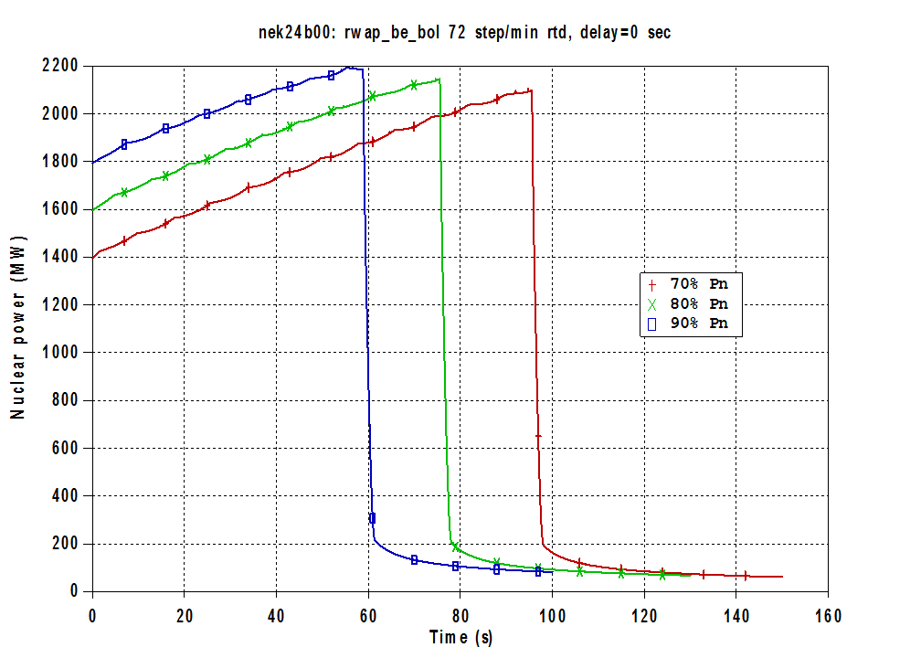Figure 1: Title of example figure.

## Equations

Each equation should be presented on a separate line from the text with a blank space above and below. Equations should be clear and expressions used should be explained in the text. The equations should be numbered consecutively at the outer right margin, as shown in Eq. (1) below. Here is one example. The Fourier series is defined as:

$f\left(x\right)=a_{0}+\sum_{n=1}^{∞}{\left(a_{n}\cos{\frac{nπx}{L}}+b_{n}\sin{\frac{nπx}{L}}\right)}$ (1)

## References

Reference numbers in the text should be designated by square brackets, e.g., [1]. The references should be listed in the same order as cited in the text. See also examples in the REFERENCES section of this template.

# CONCLUSIONS

Conclusions should state concisely the most important propositions of the paper as well as the author’s views of the practical implications of the results.

# ACKNOWLEDGEMENTS

This template was adopted from the website of the 11th International Conference of the Croatian Nuclear Society with their kind support.

**REFERENCES**

1. International Atomic Energy Agency, “Procedures for Conducting Common Cause Failure Analysis in Probabilistic Safety Assessment”, IAEA-TECDOC-648, 1992
2. K.N. Fleming, S.B. Rao, G.A. Tinsley, A. Mosleh, A. Afzali, “A Database of Common-Cause Events for Risk and Reliability Applications”, EPRI TR-100382, Electric Power Research Institute, Paolo Alto, CA., 1992
3. A. Mosleh, K.N. Fleming, G.W. Parry, H.M. Paula, D.M. Rasmuson, D.H. Worledge, “Procedures for Treating Common Cause Failures in Safety and Reliability Studies”, NUREG/CR-4780, EPRI NP-5613, Electric Power Research Institute, Paolo Alto, CA., Vol. 1 (1998), Vol. 2 (1999)
4. Relcon AB, “Risk Spectrum Professional User’s Manual”, 1998